**PROJECT REPORT TEMPLATE**

1. **INTRODUCTION:-**

1.1 Overview

* The sector is the sixth largest and ranks fifth in terms of production, consumption exports and growth. It provides employment opportunity to the rural agricultural as well as non-agricultural labourers.
* It is the source of food and fodder. It also plays an important role in international business in import and export activities.

1.2 Purpose

* Agriculture is the foundation of the Indian economy.
* The population of India mostly depends on agriculture for their livelihood and agriculture contributes to 40 percent of the total GDP of the country.

1. **PROBLEM DEFINITON & DESIGN THINKING:-**

2.1 Empathy Map

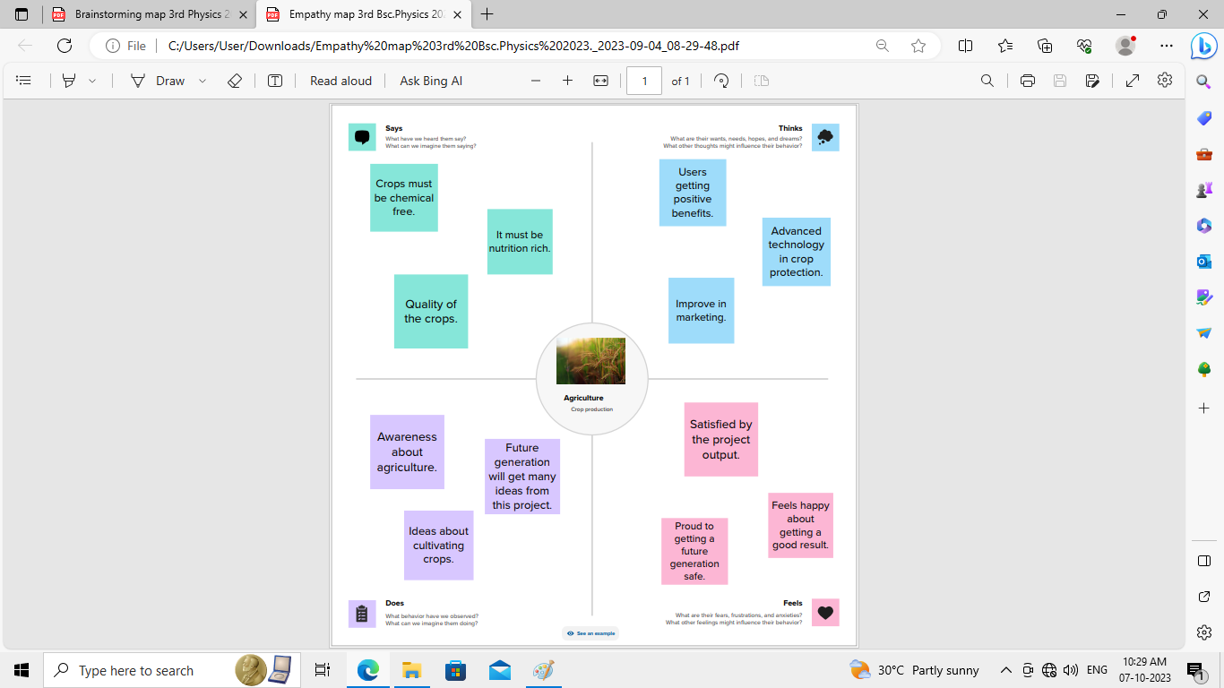

2.2 Ideation & Brainstorming Map

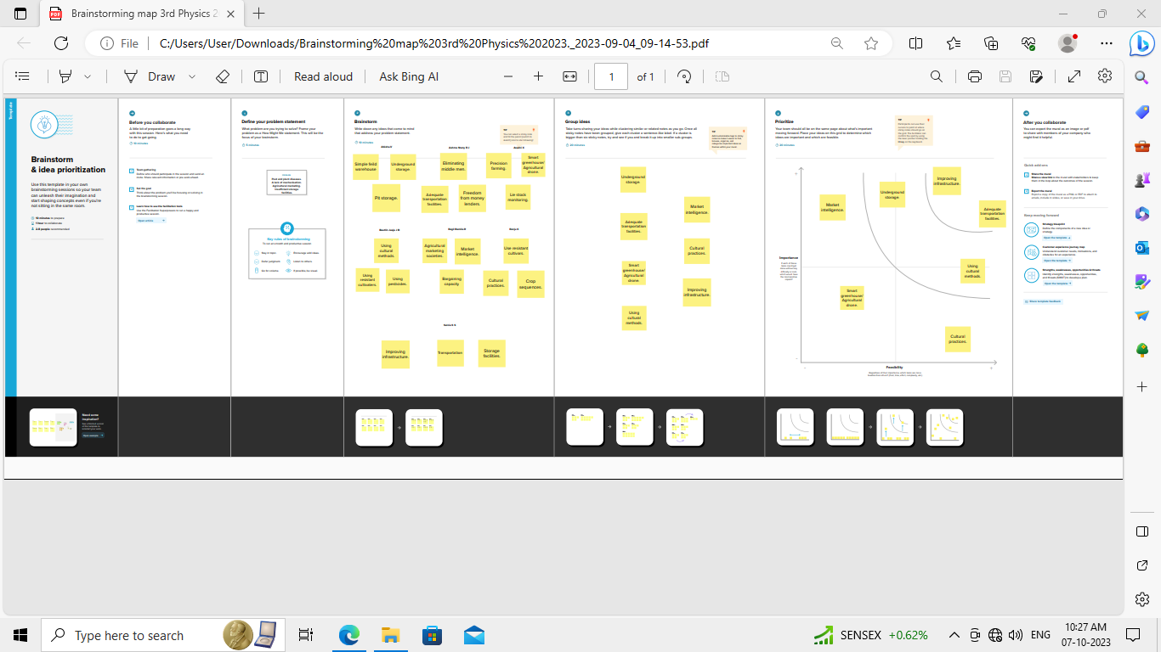

1. **RESULT:-**

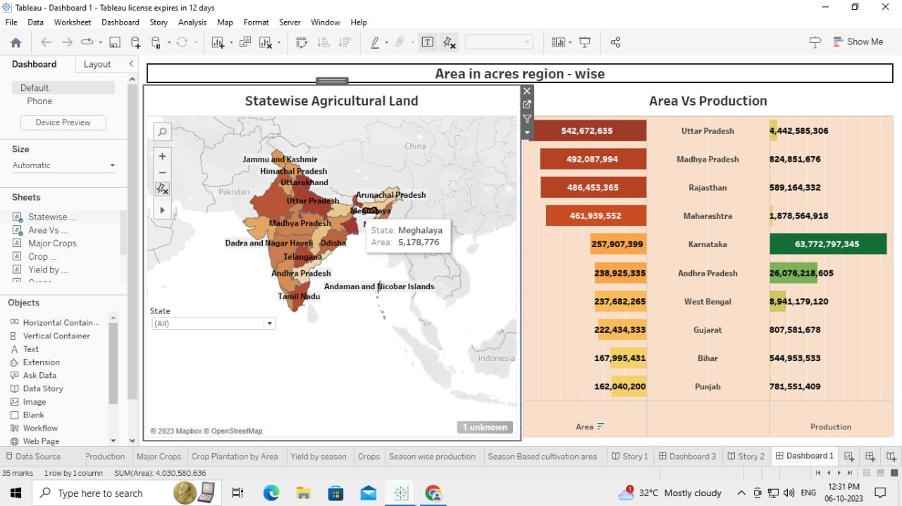

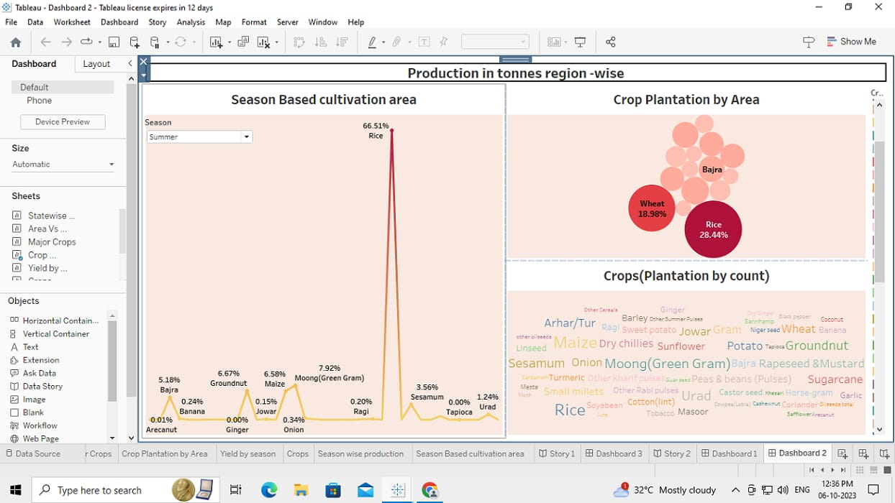

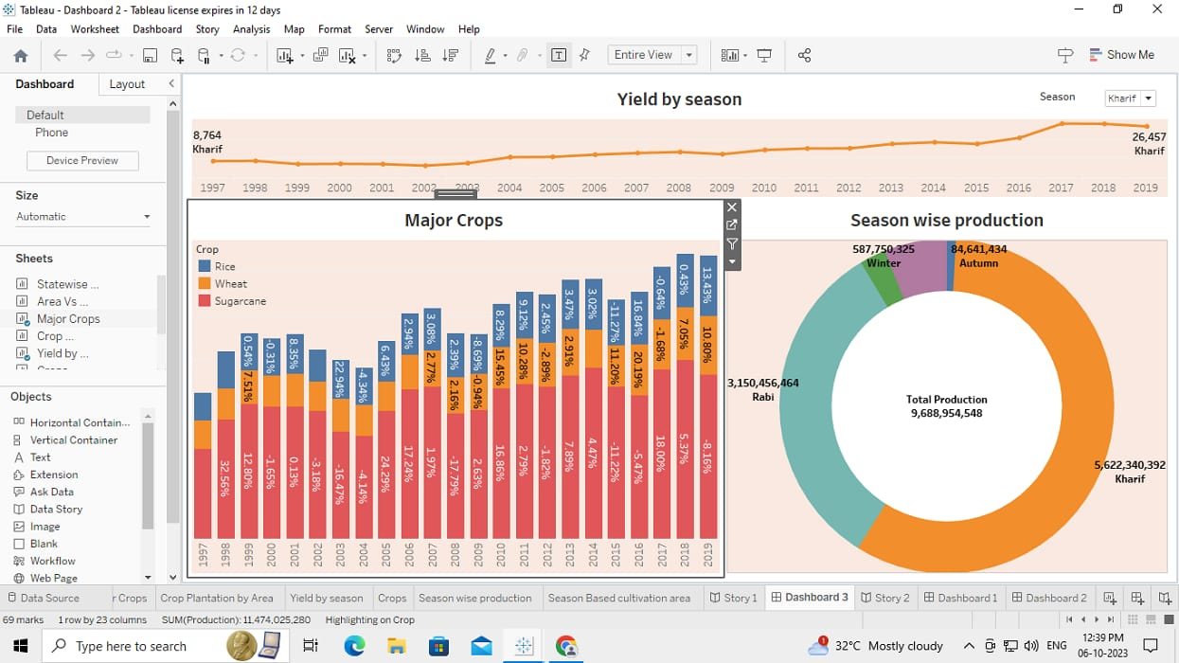

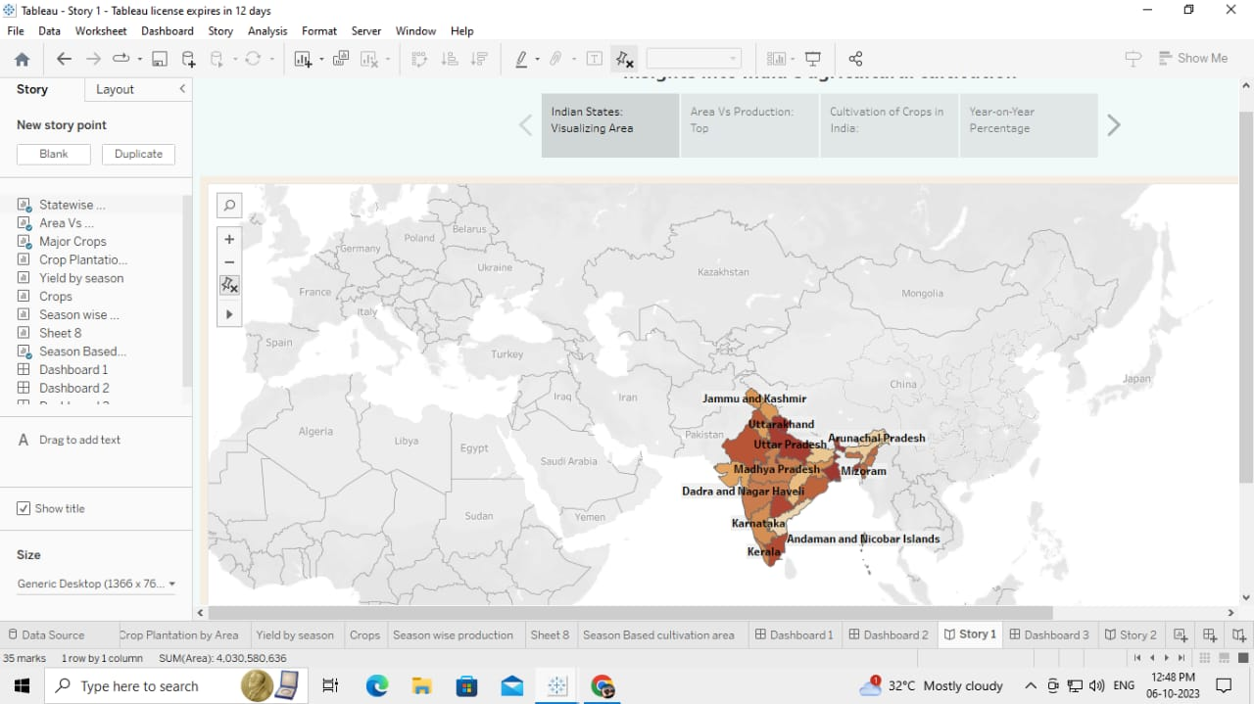

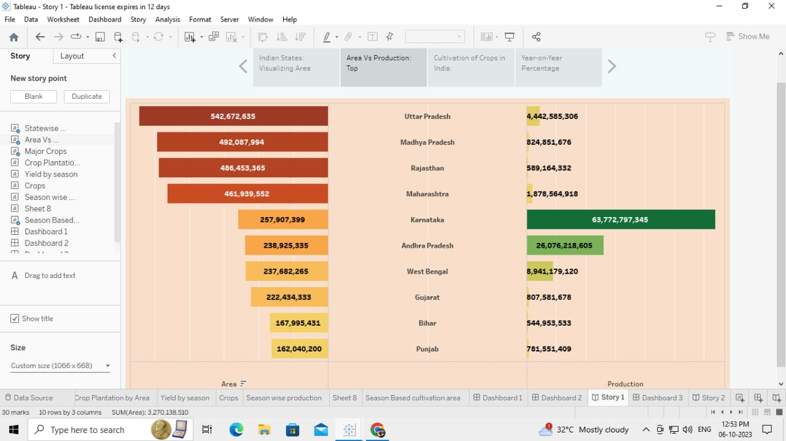

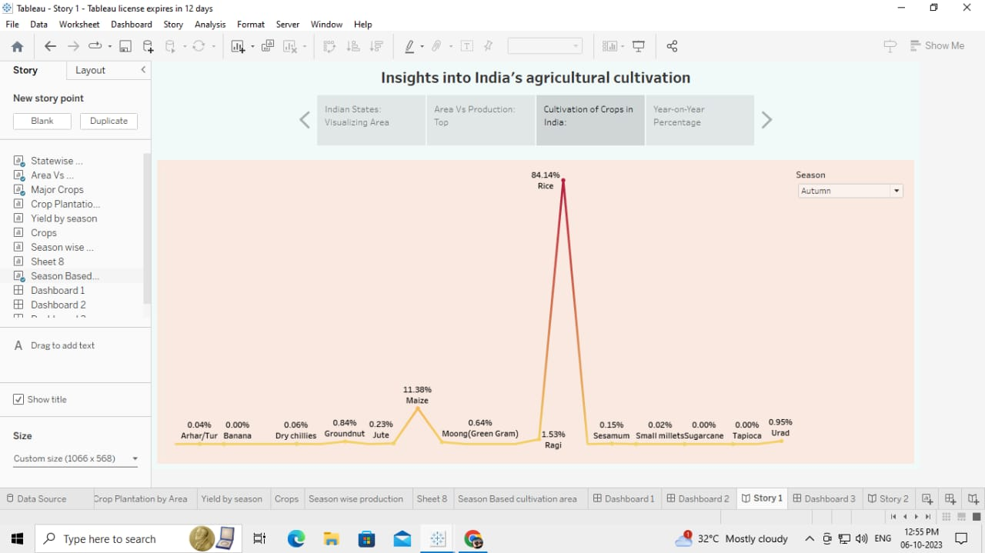

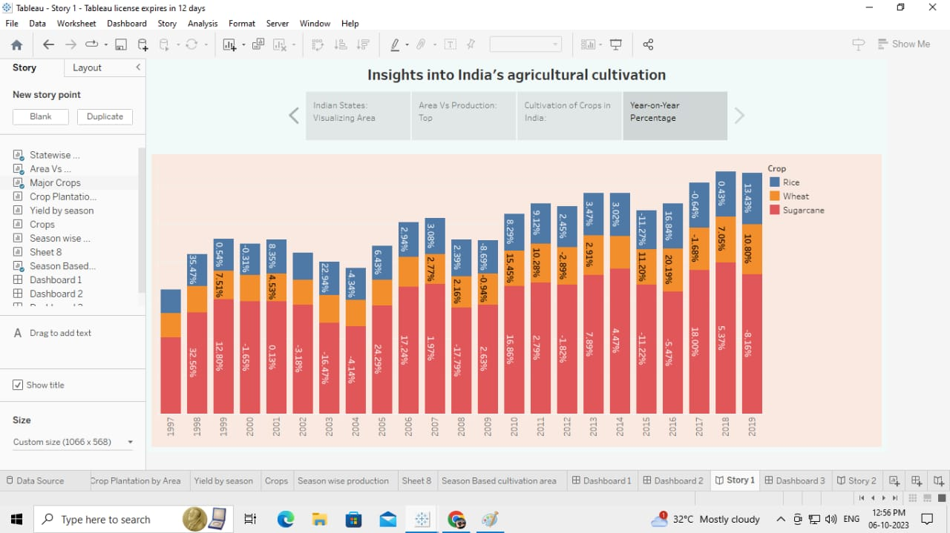

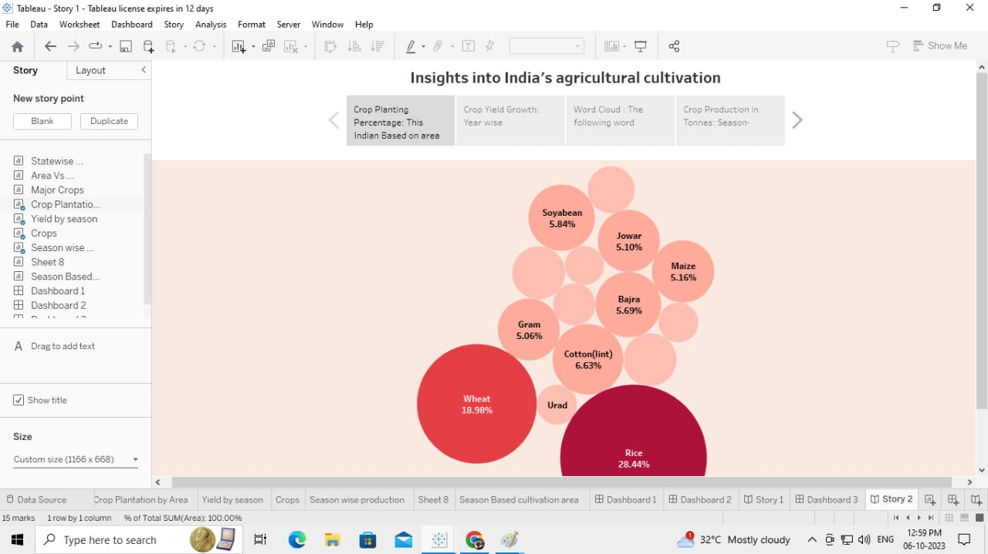

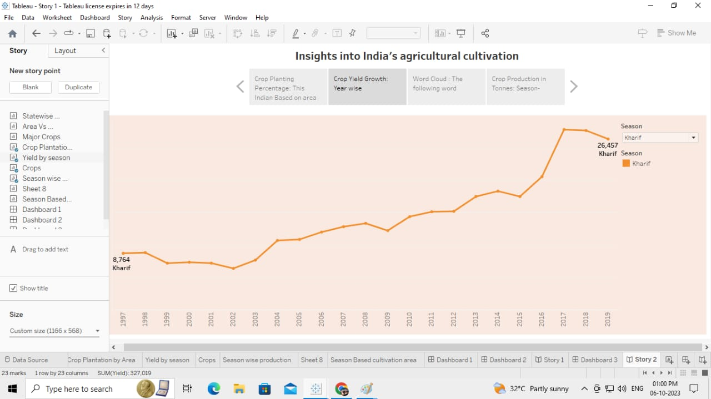

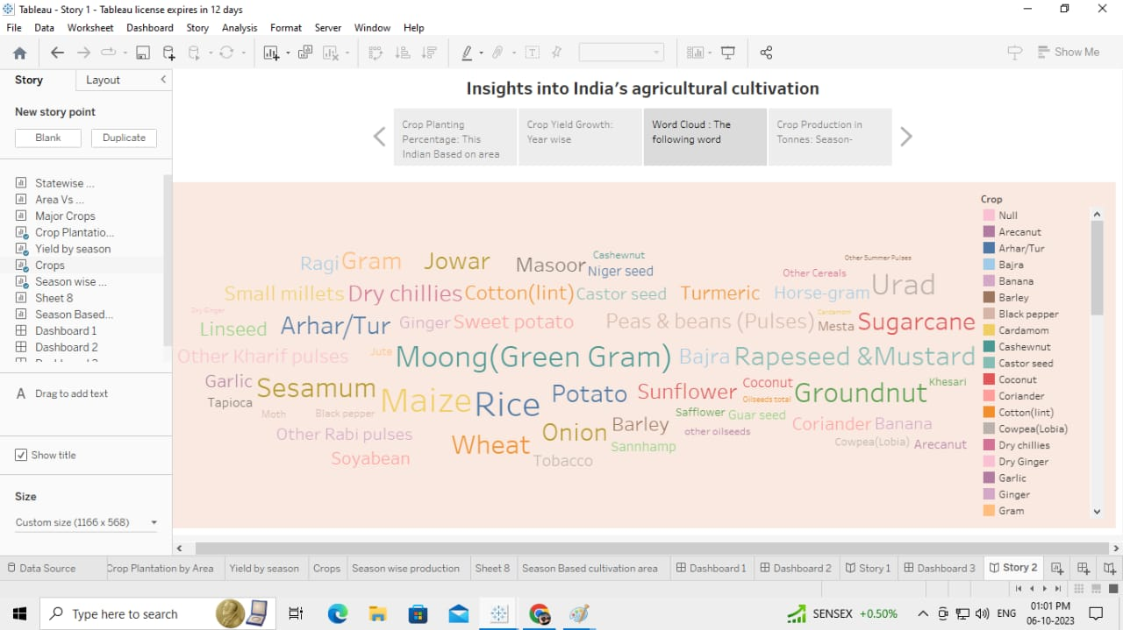

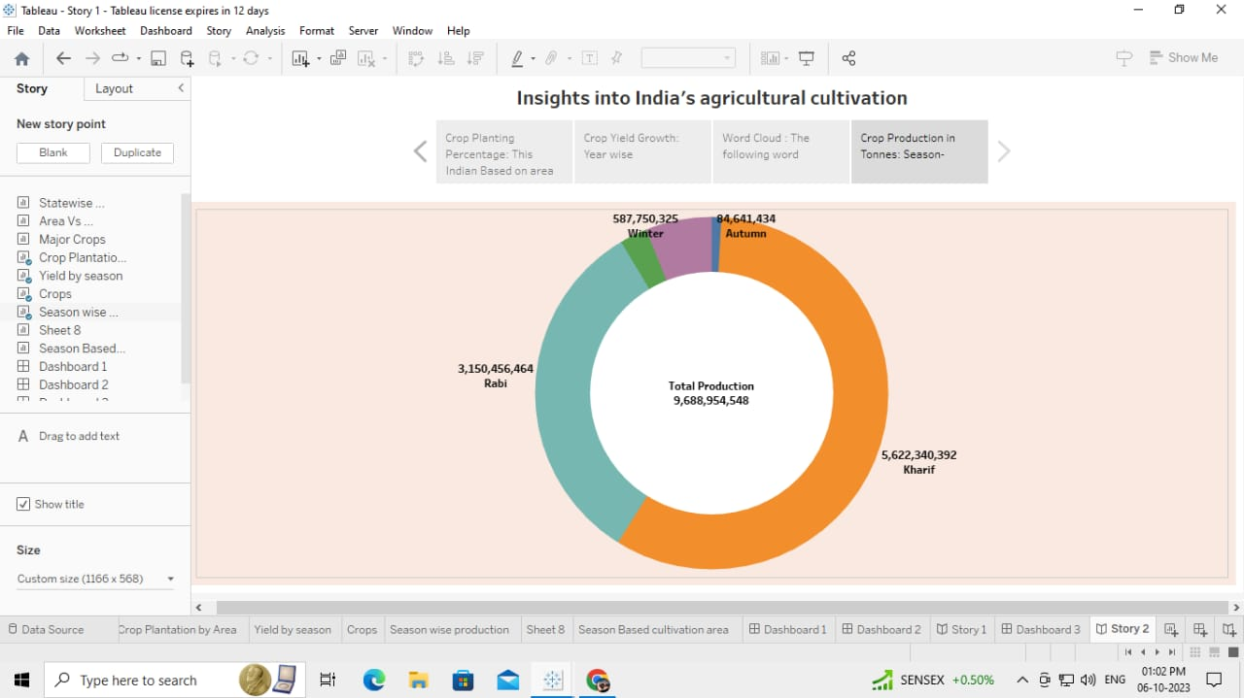

**4. ADVANTAGES:-**

* Agriculture supplies raw materials to various agro-based industries like sugar, jute, cotton textile and vanaspati industries.
* Agriculture provides a source of livelihood and also fills the needs of both animals and human alike.

**DISADVANTAGES:-**

* Erosion of soil by heavy rain floods, insufficient vegetation cover etc., reduces from productivity.
* Inadequate irrigation facilities and poor management of water resources have led to a great decline in agricultural productivity.

**5. APPLICATIONS:-**

* Agriculture and land monitoring.
* Crop Area Estimation and production forecast.
* Agriculture drought assessment and monitoring.
* Cropping systems analysis.
* Global crop programme.
* Command area and water resources monitoring.
* Pest/disease detection and incidence forecasting.

**6. CONCLUSION:-**

* The agricultural sector is of vital importance for the region.
* The Indian economy is an agro economy and depends highly on the agricultural sector.

**7. FUTURE SCOPE:-**

* There will be more of vertical and Cuban farming and there will also be efforts in long term to find new areas for production like barren deserts and seawater.